Question 2 : Find all time High price for each stock

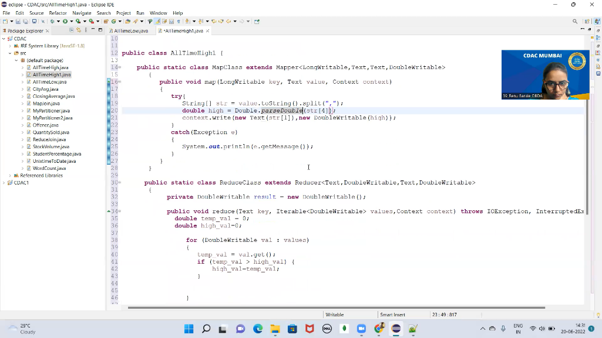

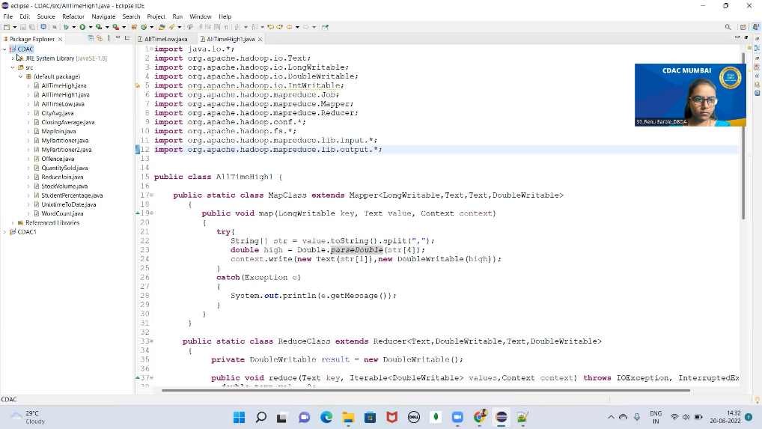



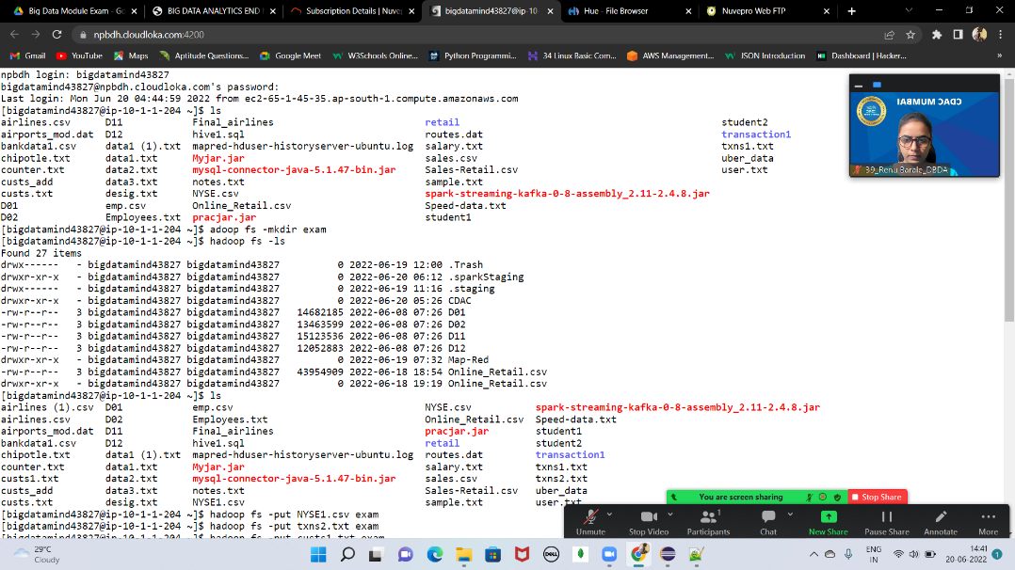

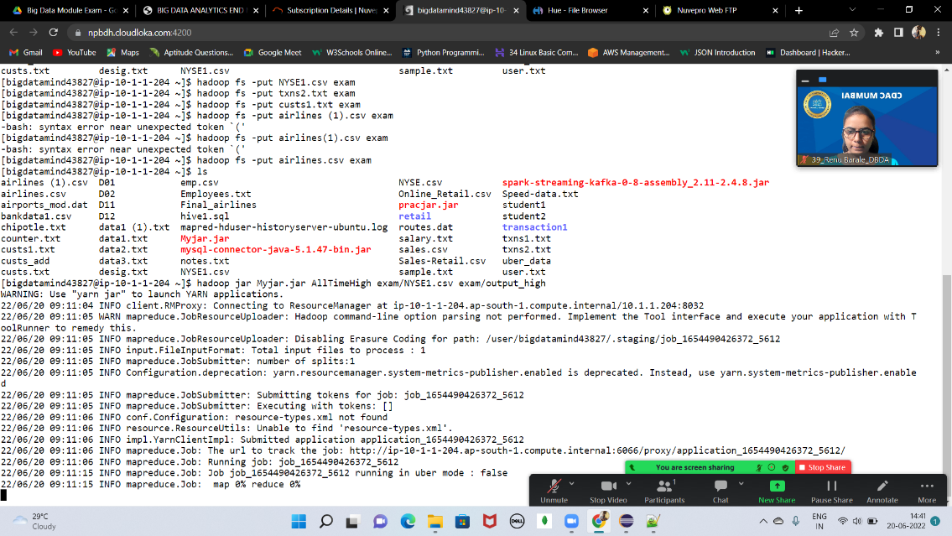

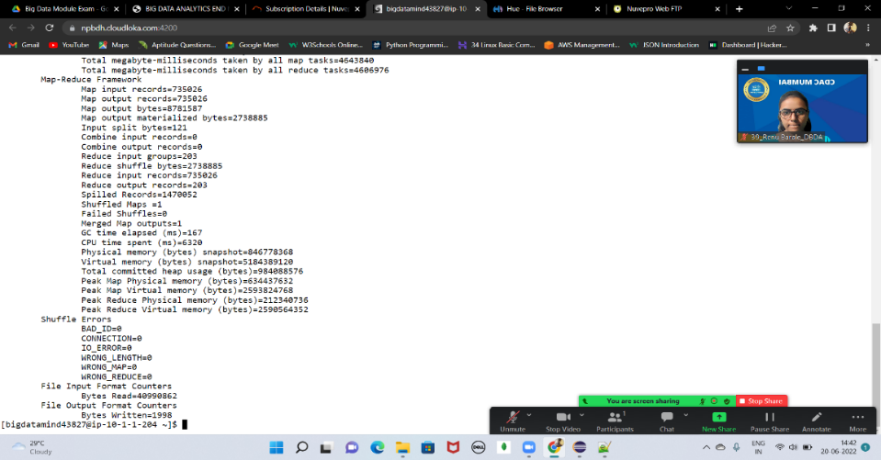

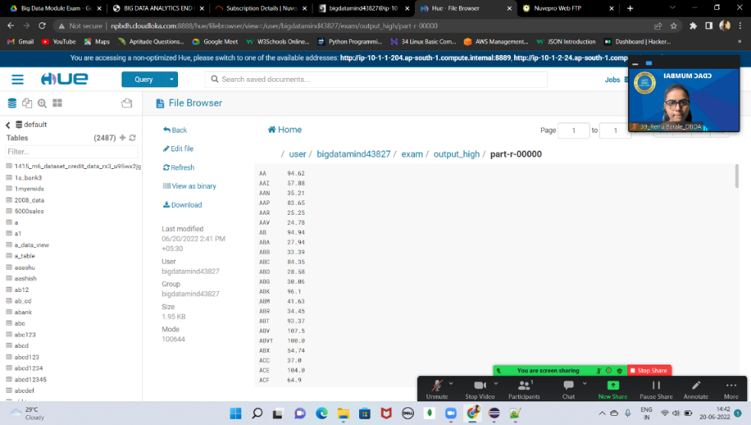

**Hive**

1. Write a program to find the count of customers for each profession

create table customer_exam(

cust_id bigint, firstname string,

lastname string, age int,

profession string

)

row format delimited

fields terminated by ','

stored as textfile ;

load data local inpath 'custs1.txt' overwrite into table customer_exam;

select profession, count(cust_id) as total_cust from customer_exam group by profession;

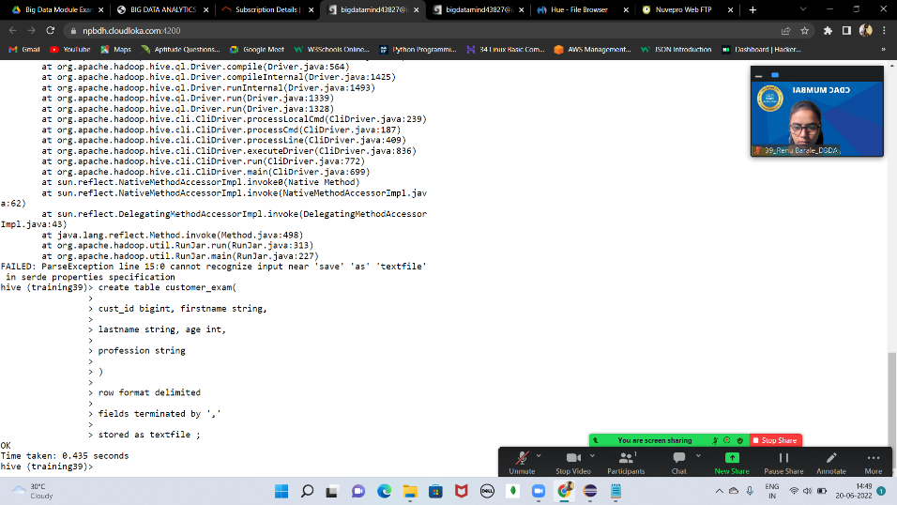

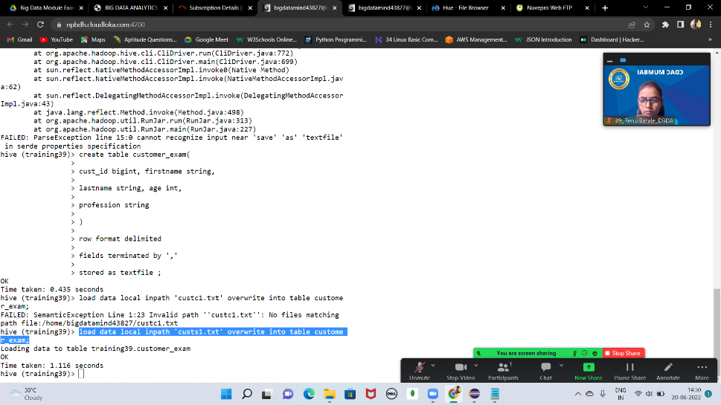

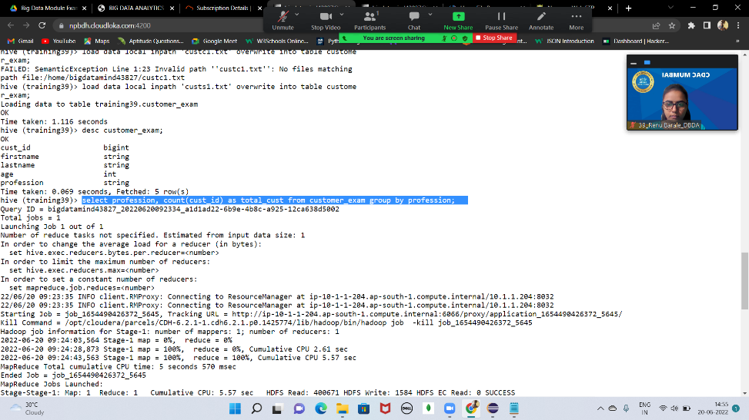

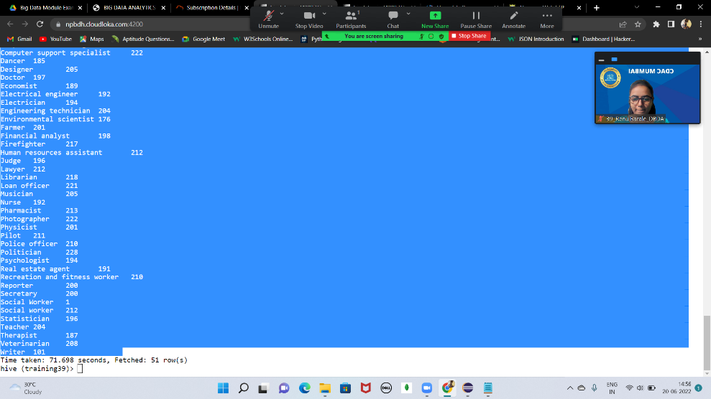

1. Write a program to find the top 10 products sales wise 3) Write a program to create partiioned table on category

create table txn_exam(

txn_id bigint,

txn_date string,

cust_id bigint,

amount bigint,

category string,

product string,

city string,

state string,

spendby string

)

row format delimited

fields terminated by ','

stored as textfile;

load data local inpath 'txns2.txt' overwrite into table txn_exam;

Q2) Write a program to find the top 10 products sales wise

==>

select product , sum(amount) as total from txn_exam group by product order by total limit 10;

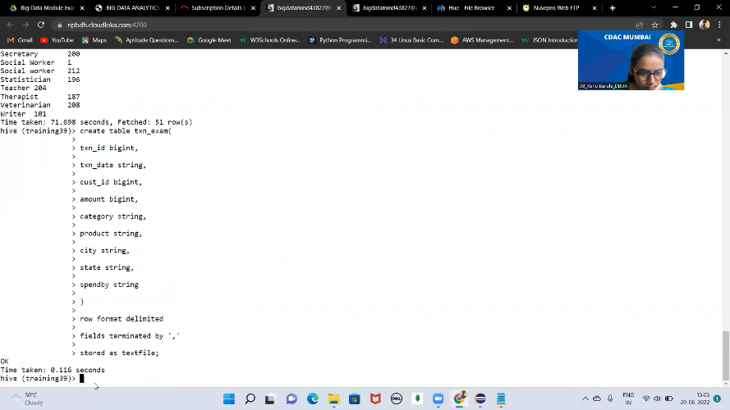

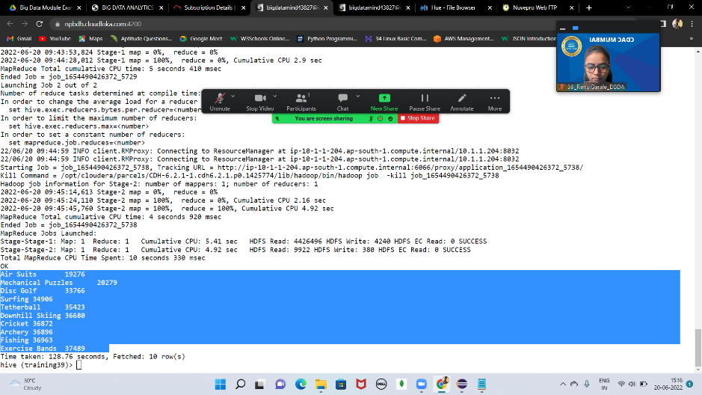

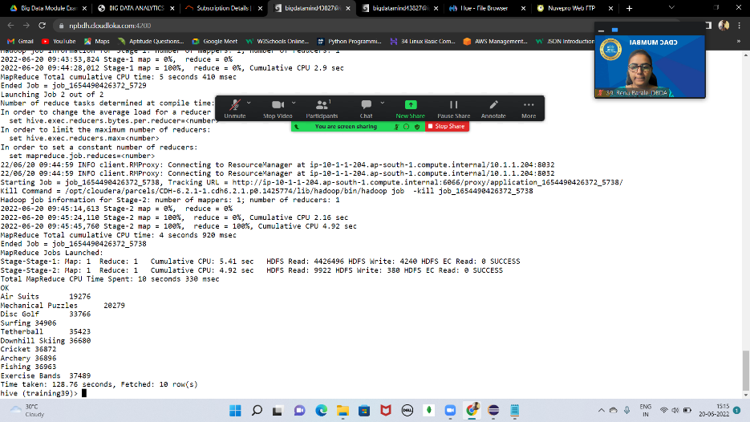

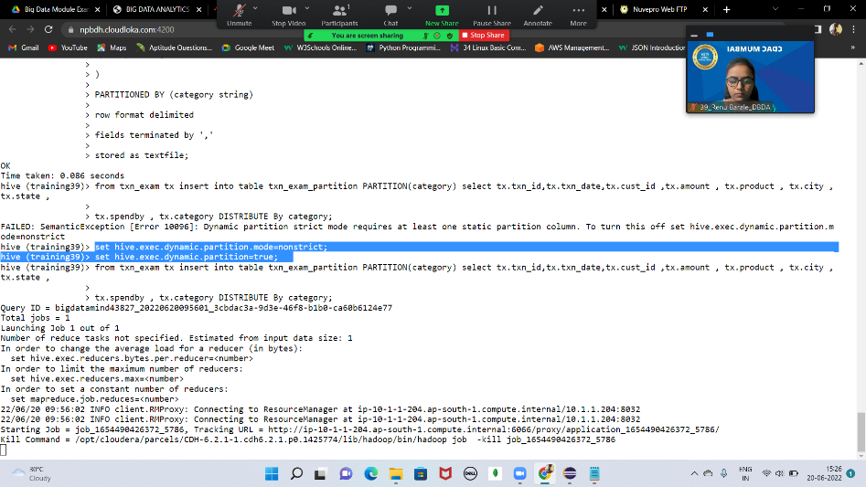

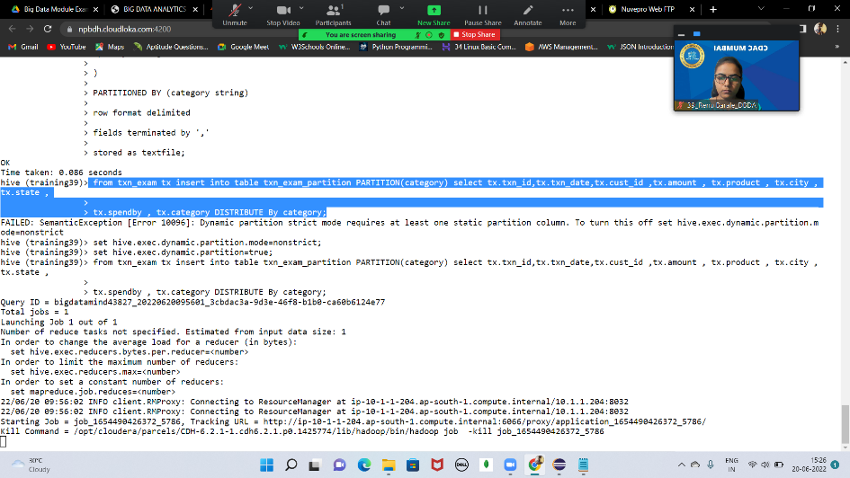

create table txn_exam_partition(

txn_id bigint,

txn_date string,

cust_id bigint,

amount bigint,

product string,

city string,

state string,

spendby string

)

PARTITIONED BY (category string)

row format delimited

fields terminated by ','

stored as textfile;

from txn_exam tx insert into table txn_exam_partition PARTITION(category) select tx.txn_id,tx.txn_date,tx.cust_id ,tx.amount , tx.product , tx.city ,tx.state ,

tx.spendby , tx.category DISTRIBUTE By category;

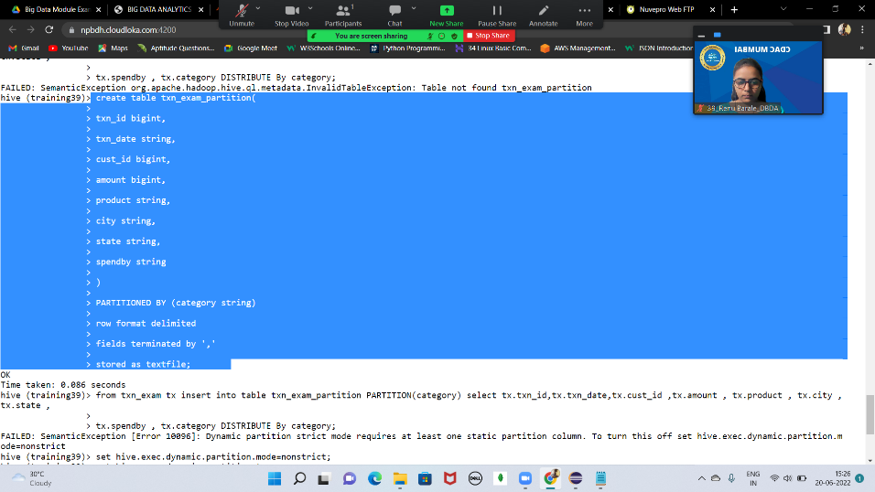

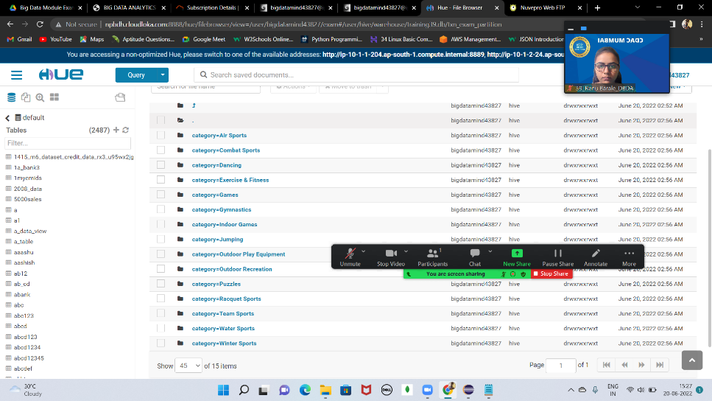

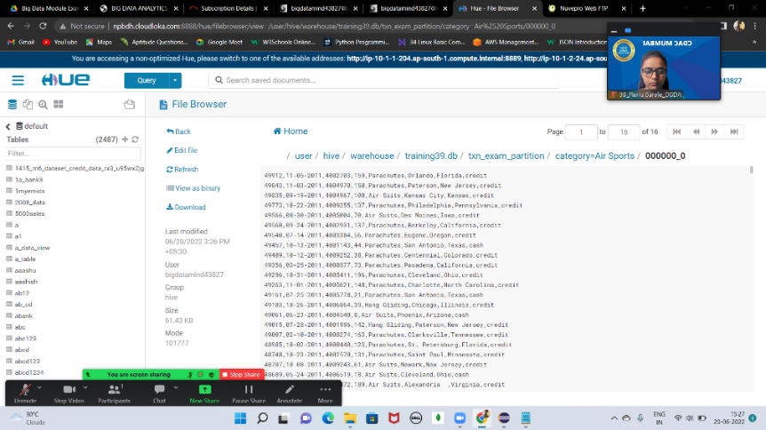

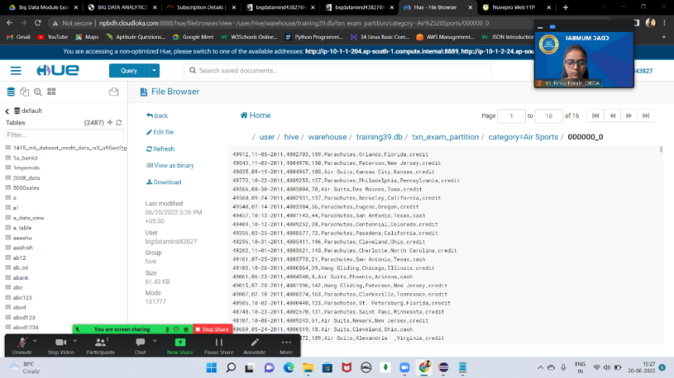

**Spark**

Q2) Identifying the highest revenue generation for which year

==>

airline_rdd=sc.textFile('/user/bigdatamind43827/exam/airlines.csv')

rdd1=airline_rdd.map(lambda a: a.encode("ascii","ignore"))

array_rdd=rdd1.map(lambda a : a.split(','))

header=array_rdd.first()

rdd2=array_rdd.filter(lambda a : a!= header)

key_value=rdd2.map(lambda a : (a[0], float (a[2]) * int (a[3]) ) )

add_total=key_value.reduceByKey(lambda a,b : a+b)

sortbyval=add_total.sortBy(lambda a: -a[1])

('2013', 66363208.71)

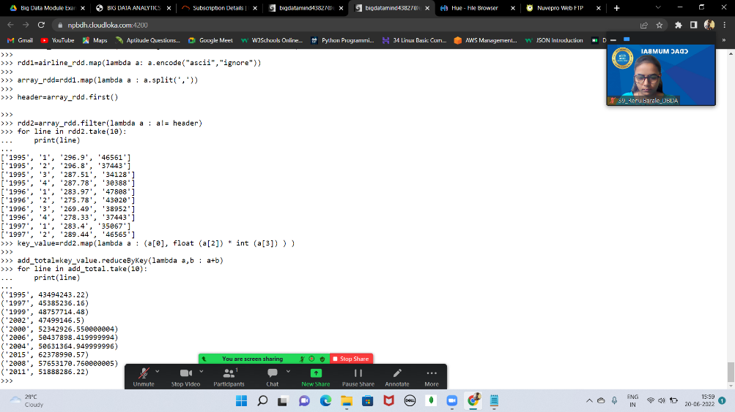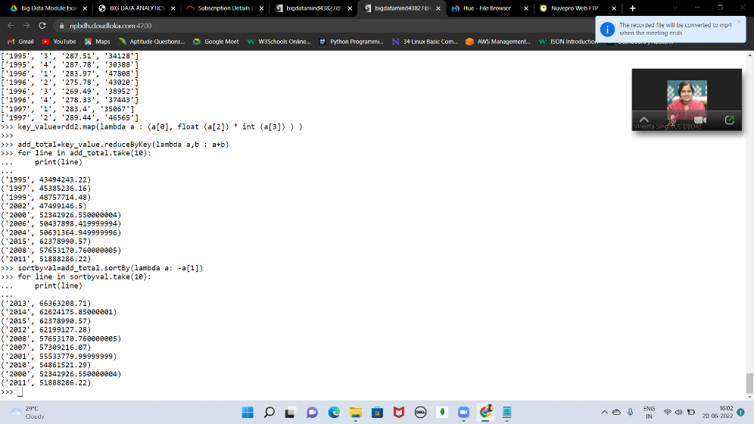

Q1)What was the highest number of people travelled in which year?

==>

key_value2=rdd2.map(lambda a : (a[0], float(a[3]) ))

add_total2=key_value2.reduceByKey(lambda a,b : a+b)

sortbyval2=add_total2.sortBy(lambda a: -a[1])

('2007', 176299.0)

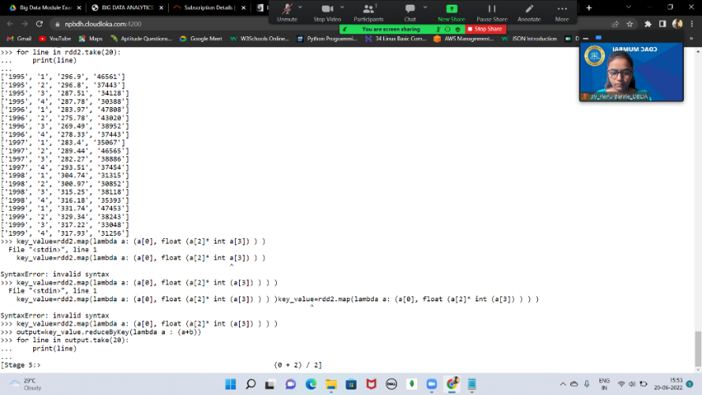

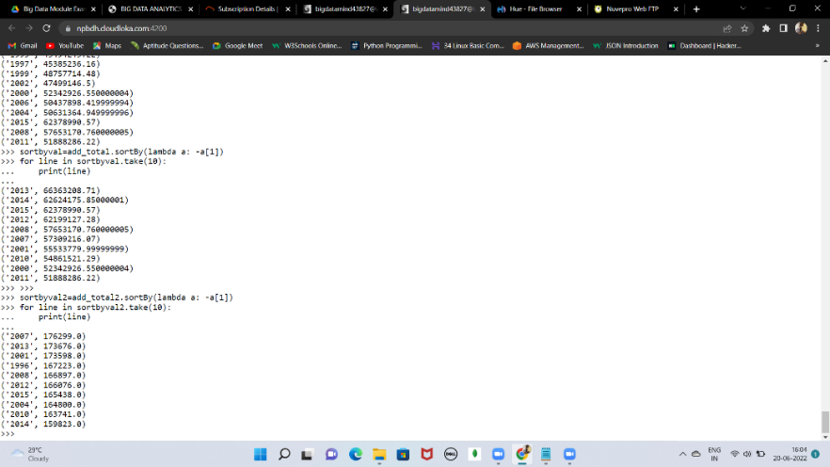

Q3)) Identifying the highest revenue generation for which year and quarter (Common

group)

==>

key_value2=rdd2.map(lambda a : ((a[0]+" "+a[1]), float(a[2])*int(a[3]) ))

add_total2=key_value2.reduceByKey(lambda a,b : a+b)

sortbyval2=add_total2.sortBy(lambda a: -a[1])

